HealthAI: Intelligent Healthcare Assistant Using IBM Granite
Category: Cloud Application Development
Skills Required: Python, IBM Cloud, Scikit-Learn

Project Description
HealthAI harnesses IBM Watson Machine Learning and Generative AI to provide intelligent healthcare assistance, offering users accurate medical insights. The platform includes:
- Patient Chat: Answer health-related questions with clear, empathetic responses.
- Disease Prediction: Evaluate user-reported symptoms to deliver potential condition predictions, likelihood assessments, and recommended next steps.
- Treatment Plans: Generate personalized, evidence-based treatment plans (medications, lifestyle modifications, follow-up testing).
- Health Analytics: Visualize and monitor patient health metrics (heart rate, blood pressure, blood glucose, etc.) with AI-driven insights.
Built with Streamlit and powered by IBM Watson and the Granite-13b-instruct-v2 model, HealthAI ensures a seamless, user-friendly experience, secure API key management, and responsible data handling—empowering users to make informed health decisions with confidence.
Scenarios
- Symptom-Driven Disease Prediction
  - Action: User inputs symptoms (e.g., headache, fatigue, mild fever).
  - Outcome: HealthAI analyzes symptoms plus patient profile, returns potential conditions with likelihoods and next-step recommendations.
- Personalized Treatment Planning
  - Action: User enters a diagnosed condition.
  - Outcome: AI generates a comprehensive treatment plan including medications, lifestyle advice, and suggested tests.
- Health Trends Insight
  - Action: User views the Health Analytics dashboard.
  - Outcome: Charts of vital signs over time appear alongside AI-generated insights highlighting concerns and improvement tips.
- On-Demand Patient Chat
  - Action: User asks any health-related question via chat interface.
  - Outcome: AI provides an empathetic, fact-based answer, acknowledges limitations, and advises when to consult a professional.

TECHNICAL ARCHITECTURE
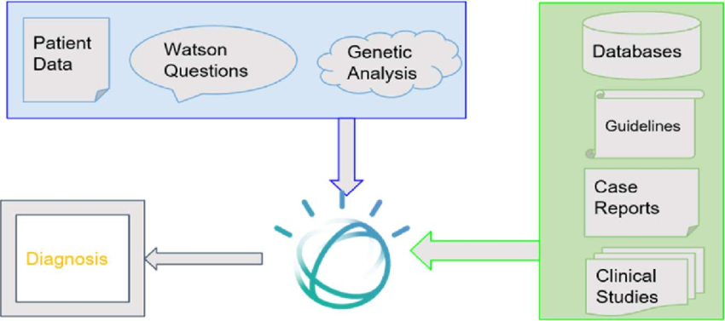
Prerequisites
- Python (3.7+)
- Streamlit for frontend UI
- IBM Watson SDK and Granite-13b-instruct-v2 model via Hugging Face (transformers, accelerate, bitsandbytes)
- Scikit-Learn (for auxiliary analytics)
- IBM Cloud Account with Watson Machine Learning service deployed
- Sufficient Hardware (≥16 GB RAM; NVIDIA GPU with ≥8 GB VRAM recommended)
- Internet Connection for initial model downloads
- Project Structure:
  - app.py (Streamlit app entry point)
  - templates/ (if using Flask alternatively)
  - static/ (CSS, images)

Project Setup & Architecture
- Model & Libraries Selection
  - Confirm Granite-13b-instruct-v2, transformers, accelerate, bitsandbytes, PyTorch, Streamlit.
- System Design
  - Input → AI inference → Data processing → Visualization → UI.
  - Secure handling of API keys and patient data.
- Development Environment
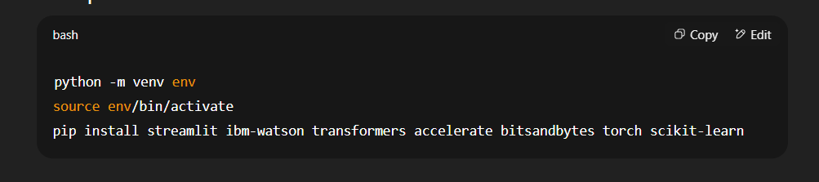
Core Functionalities
- Activity 1: Load Granite model and IBM Watson credentials.
- Activity 2: Implement Streamlit pages/components:
  - Chat input & response display
  - Symptom form → prediction
  - Condition form → treatment plan
  - Analytics charts
- Activity 3: Develop helper modules:
  - generate_response() (Granite inference)
  - predict_disease() (symptom analysis)
  - create_treatment_plan()
  - compute_health_metrics() (analytics)
- Activity 4: Secure API key/config management (e.g., using environment variables).

Data Handling & Logic
- Store session-based chat history and analytics in memory (or lightweight DB).
- Process inputs through AI functions, format outputs for UI.
- Aggregate time-series health data for insights.

Frontend Development (Streamlit)
- Layout: Sidebar navigation (Chat, Prediction, Treatment, Analytics).
- Forms & Inputs:
  - Text inputs for chat & symptoms
  - File uploader (optional) for health logs
- Visualization:
  - Line charts for vitals (Streamlit’s st.line_chart)
  - Tables for predicted conditions & treatment steps

Integration & Testing
- Local Run:
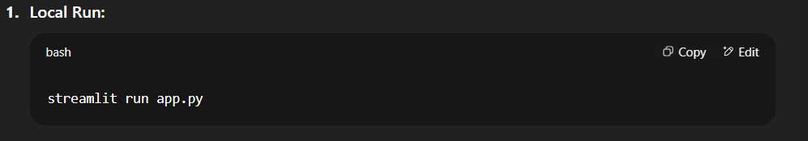
- Test Flows:
  - Chat Q&A
  - Symptom → prediction
  - Condition → treatment
  - Data upload → analytics
- Debug & Refine UI/UX based on feedback.

Deployment
- Containerize: Dockerfile with streamlit image.
- Host: IBM Cloud Run or similar.
- SSL & Security: Ensure HTTPS, secure API key storage.
- Monitoring: Track errors, usage metrics, model performance.
Documentation & Handover
- README: Setup, usage, API reference.
- User Guide: Screenshots, feature descriptions.
HealthAI delivers an end-to-end intelligent healthcare assistant—streamlining medical information access, personalized recommendations, and health analytics for better patient engagement and outcomes.

